

Registrar of Cooperative Society
RCS

“Software Requirement Specifications”

Submitted By: Submitted To:

MPSeDC, Bhopal RCS Office, M.P.
DOCUMENT CONTROL

Document Publication History

Date | Description of changes | Version | Author
26/10/2024 | SRS Draft | V_1.0 | Sumanpreet Hora

Contents
1 Introduction 4
1.1 Problem Definition 5
1.2 Purpose 5
1.3 Scope of Project 5
1.4 Stake Holders 6
2 Overall Description 6
2.1 User Characteristics 6
2.2 Constraints 6
2.3 Assumption & Dependency 6
3 Process Flow 7
3.1 Society Registration Application 7
3.2 Re-Organisation work flow 8
4 Functional Requirements 8
5 Use Cases: 9
5.1 Society Registration by Society 9
5.2 Society re-organisation 10
5.3 Amendment by laws 10
5.4 Liquidation and Revival 10
5.5 Audit process 10
6 Non-functional requirement 10
6.1 Performance Requirements 10
6.2 Software Quality Attributes 10
6.2.1 Correctness 10
6.2.2 Reliability 10
6.2.3 Adequacy 10
6.2.4 Learnability 10
6.2.5 Robustness 10
6.2.6 Maintainability: 10
6.2.7 Readability: 10
6.2.8 Extensibility: 10
6.2.9 Testability: 10
6.2.10 Efficiency: 10
6.2.11 Portability: 10
6.2.12 Availability: 10
6.3 Safety & Security 10
6.4 Reliability 10
6.5 Technical Specification & Hardware Limitations 10
Application server: 10
Purpose: 10
Database Server 10
Minimum Configuration: 10
Purpose: 10
6.6 Software Interface & coding language used to develop the product 10
6.7 DB Schema: Data Structures/Elements 10

Abbrevations and Definitions
MPSeDC : Madhya Pradesh State Electronics Development Corporation
SRS : Software Requirement Specification
RCS : Registrar of Cooperative Society
MP : Madhya Pradesh
UC : Use Case
PACS : Primary Agricultural Credit Society (PACS)
AR : Associate Registrar
DR : District Registrar
JR : Joint Registrar
GoI : Government of India
NCD : National Cooperative Database

Introduction
The goal of this document is to provide a comprehensive overview of the current operations and workflows of the Office of the Registrar of Cooperatives, detailing the registration, administration, and governance processes for societies. Key activities under this office’s purview include the Registration of Societies, Amendment of Bye-Laws, Liquidation, Revival, and De-registration of Societies. Additionally, the office is responsible for managing the Settlement of Disputes, the Election Module, Audit Automation, Inspection of subordinate offices, and various other functions such as the Housing Module, Navachar Module, Inventory Management, HRMS, Compliance/Grievances Module, and Online Membership Module. This document provides a structured examination of each area, offering insights into the current processes, existing workflows, and systems utilized by the office. By mapping out the present operational landscape, the document serves as a key tool for assessing any gaps or inefficiencies in the system.

Through a systematic evaluation of each function, this document aims to highlight areas where the current systems may be lagging and pinpoint opportunities for improvement. By gaining a deeper understanding of the processes in place, stakeholders can clearly identify bottlenecks or redundancies, laying the groundwork for process optimization and modernization. Such insights will be essential for transforming the Registrar’s Office into a more effective and citizen-responsive organization. Furthermore, the document will help align the department’s functions with current standards and expectations, ensuring an efficient and transparent operational model.

The analysis also includes a “gap analysis,” which assesses the readiness of the department to adopt e-governance. This section serves as a strategic assessment of how automation and digital systems could streamline current operations, aiming to reduce the time and labor involved in manual procedures. Transitioning to e-governance holds significant potential for enhancing operational efficiency, improving transparency, and minimizing delays. The e-governance framework seeks to modernize operations in a way that accelerates the liquidation and revival processes and provides a more citizen-centered approach in line with contemporary governance standards. Through these insights, the Office of the Registrar of Cooperatives will have a clearer pathway toward a more efficient, accessible, and responsive governance model that better meets the needs and expectations of society members and other stakeholders.

Problem Definition
Existing cooperative society data is managed through non-standardized systems, lacking integration with a centralized platform. This limits the RCS Office’s ability to access and update real-time data across the cooperative network, impacting regulatory oversight and decision-making. Furthermore, the manual process of reporting and data handling is time-consuming and prone to errors, making it challenging to support cooperative societies effectively and ensure compliance with national regulations.

Purpose
This document aims to give a brief description of the modules. With the help of this document, the needs of the organization and the solution that will be developed to cater those needs are clearly presented. In other words, this document will provide a basis for validation and verification. This document describes the project's target audience and its user interface, hardware and software requirements. It defines how our client, team and audience see the product and its functionality. Nonetheless, it helps any designer and developer to assist in software delivery lifecycle (SDLC) processes.

Scope of Project
Project scope is described as it encompasses developing or updating the RCS Office’s application in Madhya Pradesh to meet NCD data requirements, covering both common and sector-specific cooperative data. Additionally, the system will support workflows for cooperative reorganization, ensuring compliance with security and data protection standards for all cooperative society operations within the state. The scope of the developed solution forms the baseline as below:
- Registration of New Cooperatives Societies
- Bye-Law and Amendment of Bye-Laws
- Liquidation and Revival
- De- Registration of Societies
- Settlement of Disputes
- Cooperative Society Election Module
- Audit Automaton
  - Audit Allotment
  - Chartered Accountant Empanelment –e-Cooperatives Portal
  - Audit-Financial Paper Submission and Notice Generation
  - Audit Nirgaman
  - Audit Levy Memo
  - Audit Fees Remittance
  - Audit Objection and compliance
  - Annual Return Filing
- Inspection of the Subordinate Offices
- Housing Module
- Navachar Module
- Inventory Management
- HRMS
- Complaints/Grievances Redressal Module
- Online membership registration

Stake Holders
The stakeholders are anyone who get benefits from the system or who has an interest in the system. They can be affected by it either directly or indirectly. Stakeholders who will be involved in this system and their role will be described as follows:

- RCS department (HO)
- Societies
- Citizens (Farmers, members of societies, etc)
- District Office
- Divisional Office
- Apex institutes
- External Auditor
- Ministry of corporation (GoI)

Overall Description

User Characteristics
Users of application are characterized as follows:
- A moderate level of computer literacy and shall use the application mainly from the office.
- A moderate level of internet literacy.

Constraints
- Changes in the basic way of functionality, changes in rules at the client-side may affect system design options.
- The reliability of requirements collected from the RCS department shall depend on the information/ details provided by department officials. The non-reliable information shall affect the software design and development option.
- The system shall provide security based on the organizational structure of the department. Only the specified users shall be able to read, write or update the data. It is proposed that the system shall provide logins and passwords for a user to log into the system.
- Access to viewing and printing of some reports/ data shall be different for different users. The system will abide by the security-related aspects that will be governed by MP RCS Department.

Assumption & Dependency
- Beneficiary personal details will be fetched from Samagra Id.
- Society data will be fetched from NCD
- It is assumed that internet connectivity is available.
- It is assumed that departmental users are well versed in using web applications.
- User will enter valid and authentic data into the system.
- The system will validate identified user inputs. However, factual inputs cannot be validated by the system for which, the user will need to enter valid data.
- The system will be designed, assuming that, required system software, middleware, and connectivity hardware resource are available in working conditions

Process Flow

Society Registration Application
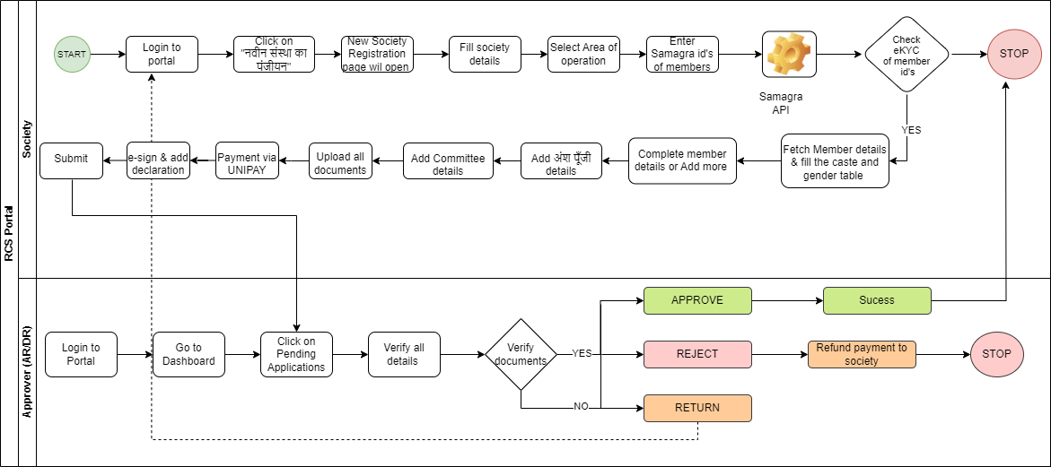

Re-Organisation work flow
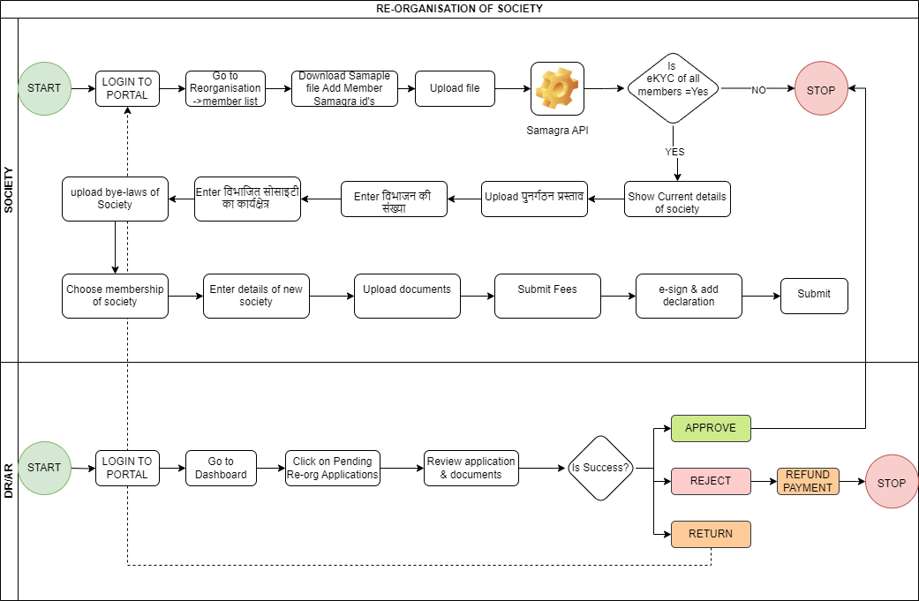

Functional Requirements
S.no. | Module | Requirement
1 | User management | Provision to add user to the portal
2 | User management | Provision to assign role & permission to the registered user
3 | Society Registration | Re-design the existing society registration page with additional fields required to integrate with NSD
4 | Society Registration | Hierarchy management for society allocation
5 | Society Registration | Provision to upload cooperative documents as per the pre-defined checklist
6 | Society Registration | Provision to add members to the registered society up to 21 members using Samagra ID
7 | Society Registration | Provision to upload member photograph and Aadhaar based e-sign
8 | Society Registration | Provision to declare society area, gram, assets
9 | Society Registration | DR shall have the provision to change the classification of society
10 | Society Registration | In society registration, prefix society name with सहकारी संस्था as default
11 | Society Registration | for field दायतित्व का प्रकार- show समिति as default value
12 | Society Registration | Add fields like Application status, cooperative ID, Registration Authority, Registration date, Year, area of operation (कार्यक्षेत्र), location of registration, Designation of Primary application, Sector of Operation, Primary Activity, Tier of cooperative society, Whether Area of Operation  (Village, Panchayat, Block or Mandal or Town, Taluka/District) is adjacent to or includes water body, Whether the cooperative society is affiliated to Union/Federation, Number of Members of the Cooperative Society as per gender, Audit Details - Whether Financial Audit has been done?, Year of Latest Audit Completed, Whether the Cooperative Society is profit making?, Net Profit of the Cooperative Society, Select the type of bank where the cooperative society have a bank account?, Category of Audit, Whether the dividend paid by the Cooperative Society?, Select the name of the bank where the cooperative society has its bank account, What is the score of the Audit?
13 | Payment via UNIPAY | There shall be provision to pay registration fees via UNIPAY and return payment status to system
14 | Society Registration | Populate table of membership of society based on Gender and Caste as per data received from Samagra
15 | Society Registration

Use Cases:

Society Registration by Society
Use Case ID | UC_01
Name of Use Case | Society Registration by Society
Created by | Sumanpreet Hora | Last Updated by | -
Date Created | 01st Nov 2024 | Last Revision Date | -
Description | The use case describes the society registration initiation and details submission in the portal.
Actor | Society Representative
Pre-condition | - Society representative has access to the RCS Portal and Samagra IDs of society members.
Post-condition | - eKYC check is successful, and the system fetches member details, including caste and gender.  - Society registration application is successfully submitted to the portal.
Flow | - Society representative logs into the RCS Portal.  - Clicks on the "नवीन संस्था का पंजीयन" (New Society Registration) option.  - Fills in society details and selects the area of operation.  - Enters the Samagra IDs of members.  - The system checks the eKYC of the member IDs through the Samagra API.  - Adds member details if more need to be added.  - Completes the committee details and other necessary details.  - Uploads all required documents.  - Pays the registration fee through UNIPAY.  - E-signs the application and check self-declaration  - Submits the application.

Use Case ID | UC_02
Name of Use Case | Society Registration Application Review by Approver (ARD/DR)
Created by | Sumanpreet Hora | Last Updated by | -
Date Created | 01st Nov 2024 | Last Revision Date | -
Description | The use case describes the review process of received society registration application in the portal.
Actor | Approver (ARD/DR)
Pre-condition | Society has successfully submitted the registration application.
Post-condition | Application is either approved, rejected, or returned for further updates
Flow | - Approver logs into the RCS Portal.  - Goes to the dashboard and selects pending applications.  - Reviews the submitted application details and verifies the documents.  - If documents are valid, the approver approves the application.  - If there are issues with the application or documents, the approver can either reject or return the application.

Use Case ID | UC_03
Name of Use Case | Society Registration Application Approval
Created by | Sumanpreet Hora | Last Updated by | -
Date Created | 01st Nov 2024 | Last Revision Date | -
Description | The use case describes the process of received society registration application approval process in the portal.
Actor | Approver (ARD/DR)
Pre-condition | - Society has successfully submitted the registration application.  - Approver has verified all application details and documents.
Post-condition | Society registration is completed, and the society is successfully registered
Flow | - Approver selects the application for approval.  - Approver marks the application as "Approved."  - The status updates to "Success” in the system

Use Case ID | UC_04
Name of Use Case | Society Registration Application Rejected
Created by | Sumanpreet Hora | Last Updated by | -
Date Created | 01st Nov 2024 | Last Revision Date | -
Description | The use case describes the process of received society registration application rejection process in the portal.
Actor | Approver (ARD/DR)
Pre-condition | - Society has successfully submitted the registration application.  - Approver has verified all application details and documents.
Post-condition | Application is rejected, and the society is informed via WhatsApp/SMS/email
Flow | - Approver selects the application for rejection.  - Marks the application as "Rejected."  - The system initiates a refund of the payment to the society.  - Notification is sent to society of rejection of application with appropriate reason

Use Case ID | UC_05
Name of Use Case | Society Registration Application Returned
Created by | Sumanpreet Hora | Last Updated by | -
Date Created | 01st Nov 2024 | Last Revision Date | -
Description | The use case describes the process of received society registration application returned process in the portal.
Actor | Approver (ARD/DR)
Pre-condition | - Approver finds missing or incorrect information in the application.
Post-condition | Society representative can log in, make necessary updates, and resubmit the application.
Flow | - Approver selects the application to return for corrections.  - Marks the application as "Returned," specifying the details needed.  - Society representative receives notification to update the application via WhatsApp/SMS/email.

Society re-organisation
Use Case ID | UC_01
Name of Use Case | Initiating Re-organization of Society
Created by | Sumanpreet Hora | Last Updated by | -
Date Created | 01st Nov 2024 | Last Revision Date | -
Description | The use case describes the society re-organisation and details submission in the portal.
Actor | Society Representative
Pre-condition | Society representative has access to the RCS Portal and has the Samagra IDs of society members.
Post-condition | - If all member eKYCs are verified, the process continues  - eKYC check is successful, and the system fetches member details, including caste and gender.
Flow | - Society representative logs into the RCS Portal.  - Navigates to the "Reorganization" section and selects "Member List."  - Downloads the sample file to add the Samagra IDs of members.  - Uploads the file with member details.  - The system performs an eKYC check of all members through the Samagra API.

Use Case ID | UC_02
Name of Use Case | Entering Re-organization Details
Created by | Sumanpreet Hora | Last Updated by | -
Date Created | 01st Nov 2024 | Last Revision Date | -
Description | The use case describes the society re-organisation and details submission in the portal.
Actor | Society Representative
Pre-condition | Society representative has access to the RCS Portal and has the Samagra IDs of society members.
Post-condition | - The society's reorganization details are successfully recorded in the system
Flow | - The system shows the current details of the society.  - Society representative uploads the reorganization proposal (पुनर्गठन प्रस्ताव).  - Enters the operational area of the society (विभाजित सोसाइटी का कार्यक्षेत्र).  - Enters the number of divisions (विभाजन की संख्या).  - Uploads the bye-laws of the society.  - Chooses the membership type of the society.  - Enters details of the new society.  - Uploads any additional required documents.  - Submits the fees through the portal.  - E-signs the declaration  - Submits the reorganization application.

Use Case ID | UC_03
Name of Use Case | Reviewing Re-organization Application
Created by | Sumanpreet Hora | Last Updated by | -
Date Created | 01st Nov 2024 | Last Revision Date | -
Description | The use case describes the reviewing of society re-organisation application and details submitted in the portal.
Actor | Approver (DR/AR)
Pre-condition | Society has successfully submitted the reorganization application.
Post-condition | Approver decides to approve, reject, or return the application based on the review.
Flow | - Approver logs into the RCS Portal.  - AR lands to the dashboard and selects "Pending Re-org Applications."  - Reviews the application and all associated documents.  - Checks if the application meets the necessary requirements and is complete

Use Case ID | UC_04
Name of Use Case | Society Registration Application Approval
Created by | Sumanpreet Hora | Last Updated by | -
Date Created | 01st Nov 2024 | Last Revision Date | -
Description | The use case describes the process of received society registration application approval process in the portal.
Actor | Approver (ARD/DR)
Pre-condition | - Society has successfully submitted the registration application.  - Approver has verified all application details and documents.
Post-condition | Society registration is completed, and the society is successfully registered
Flow | - Approver selects the application for approval.  - Approver marks the application as "Approved."  - The status updates to "Success” in the system

Use Case ID | UC_05
Name of Use Case | Society Registration Application Rejected
Created by | Sumanpreet Hora | Last Updated by | -
Date Created | 01st Nov 2024 | Last Revision Date | -
Description | The use case describes the process of received society registration application rejection process in the portal.
Actor | Approver (ARD/DR)
Pre-condition | - Society has successfully submitted the registration application.  - Approver has verified all application details and documents.
Post-condition | Application is rejected, and the society is informed via WhatsApp/SMS/email
Flow | - Approver selects the application for rejection.  - Marks the application as "Rejected."  - The system initiates a refund of the payment to the society.  - Notification is sent to society of rejection of application with appropriate reason

Use Case ID | UC_06
Name of Use Case | Society Registration Application Returned
Created by | Sumanpreet Hora | Last Updated by | -
Date Created | 01st Nov 2024 | Last Revision Date | -
Description | The use case describes the process of received society registration application returned process in the portal.
Actor | Approver (ARD/DR)
Pre-condition | - Approver finds missing or incorrect information in the application.
Post-condition | Society representative can log in, make necessary updates, and resubmit the application.
Flow | - Approver selects the application to return for corrections.  - Marks the application as "Returned," specifying the details needed.  - Society representative receives notification to update the application via WhatsApp/SMS/email.

Use Case ID | UC_07
Name of Use Case | Downloading Sample File for Member Information
Created by | Sumanpreet Hora | Last Updated by | -
Date Created | 01st Nov 2024 | Last Revision Date | -
Description | The use case describes the process of processing member information in the registered society in the portal.
Actor | Society Representative
Pre-condition | Society representative has logged into the RCS Portal and navigated to the reorganization section.
Post-condition | Society representative can log in, make necessary updates, and resubmit the application.
Flow | - Society representative clicks on "Download Sample File" to get the format for adding member Samagra IDs.  - Opens the downloaded file and fills in the Samagra IDs of all society members as per the format.  - Saves the file for uploading.

Use Case ID | UC_07
Name of Use Case | Downloading Sample File for Member Information
Created by | Sumanpreet Hora | Last Updated by | -
Date Created | 01st Nov 2024 | Last Revision Date | -
Description | The use case describes the process of processing member information of the registered society in the portal.
Actor | Society Representative
Pre-condition | Society representative has logged into the RCS Portal and navigated to the reorganization section.
Post-condition | Society representative can log in, make necessary updates, and resubmit the application.
Flow | - Society representative clicks on "Download Sample File" to get the format for adding member Samagra IDs.  - Opens the downloaded file and fills in the Samagra IDs of all society members as per the format.  - Saves the file for uploading.  - Society representative uploads the file containing Samagra IDs to the portal.  - The system verifies the file format and content.  - If the format is correct, the file is accepted for processing; if not, an error message is displayed.

Use Case ID | UC_08
Name of Use Case | eKYC Verification of Members
Created by | Sumanpreet Hora | Last Updated by | -
Date Created | 01st Nov 2024 | Last Revision Date | -
Description | The use case describes the process of eKYC verification of members of the registered society.
Actor | System (RCS Portal, Samagra API)
Pre-condition | Society representative has uploaded a file with valid Samagra IDs.
Post-condition | eKYC is completed successfully for all members, or the process is halted if any verifications fail.
Flow | - The system sends the member Samagra IDs to the Samagra API for eKYC verification.  - The Samagra API verifies each member's identity and returns the result to the RCS Portal.  - If eKYC verification for all members is successful, the process continues; otherwise, it stops, and the society representative is informed of the failure.

Use Case ID | UC_09
Name of Use Case | Refund processing Upon Rejection of application
Created by | Sumanpreet Hora | Last Updated by | -
Date Created | 01st Nov 2024 | Last Revision Date | -
Description | The use case describes the refund process of rejection of application
Actor | System (RCS Portal)
Pre-condition | Approver has rejected the reorganization application.
Post-condition | Society receives a refund
Flow | - The DR marks the application as rejected.  - Initiates a refund process to return any fees paid by the society.  - Sends notification to the society about the rejection and the refunded payment.

Amendment by laws
Use Case ID | UC_01
Name of Use Case | Process flow in amendments bye-laws
Created by | Sumanpreet Hora | Last Updated by | -
Date Created | 01st Nov 2024 | Last Revision Date | -
Description | This use case describes the process of making amendments in existing bye-laws of society
Actor | Society Representative
Pre-condition | - The society is registered and has access to the RCS Portal.  - Society representative has login credentials for the portal.  - Proposed amendments to the bye-laws are prepared and documented.
Post-condition | - Amendment application is either approved, rejected, or returned for further modifications.  - Society receives notification of the final decision
Flow | - Society representative login to the portal  - Navigate to Society Management -> Bye Laws  - List of all bye-laws of the society will be visible  - Select the bye-law to be amended, add justification of amendment  - Upload amended bye-laws and mention reason for amendment  - Submit the application

Use Case ID | UC_02
Name of Use Case | Approval flow in amendments bye-laws
Created by | Sumanpreet Hora | Last Updated by | -
Date Created | 01st Nov 2024 | Last Revision Date | -
Description | This use case describes the approval process of amendments in existing bye-laws of society
Actor | Approver
Pre-condition | - The society is registered  - Proposed amendments to the bye-laws are prepared and documented.
Post-condition | - Amendment application is either approved, rejected, or returned for further modifications.  - Society receives notification of the final decision
Flow | - Approver login to the portal  - Navigate to Society Management -> Bye Laws  - List of all bye-laws of the society and amendment in bye-laws will be visible to AR  - Review reason of amendment and supporting document  - Based on the review application can be either: Approved, Rejected or Return  - Society will be notified as the decision of approver via SMS/WhatsApp

Use Case ID | UC_03
Name of Use Case | Amendment bye-laws Application Approval
Created by | Sumanpreet Hora | Last Updated by | -
Date Created | 01st Nov 2024 | Last Revision Date | -
Description | The use case describes the process of received application of amendment in Bye-laws approval process in the portal.
Actor | Approver (ARD/DR)
Pre-condition | - Society has successfully submitted the amendment in bye-laws application.  - Approver has verified all application details and documents.
Post-condition | Society bye-laws will be amended successfully
Flow | - Approver selects the application for approval.  - Approver marks the application as "Approved."  - The status updates to "Success” in the system

Liquidation and Revival

Audit process

Integrations
- National Cooperative Database (NCD)
- Samagra
- UNIPAY
- WhatsApp
- SMS

Non-functional requirement

Performance Requirements
Technical performance requirements: The portal will be able to work as quickly as possible without any unnecessary time delay. A performance requirement specifies the speed or operational effectiveness of a capability that must be delivered by the system architecture. Functional requirements address the needs and behaviour’s required by the user community while performance requirements address the speed and effectiveness of the overall architecture. The critical difference between these two types of requirements and testing them is that functional requirements deal with the business while performance requirements deal with the architecture.
The testing levels include: Check CPU load on the pilot on full load.

Software Quality Attributes
The provided solution will take care of the following Software Quality Attributes:
- Correctness
- Reliability
- Adequacy
- Learnability
- Robustness
- Maintainability
- Readability
- Extensibility
- Testability
- Efficiency
- Portability
- Availability

Correctness
The correctness of a software system refers to:
- Agreement of program code with specifications
- Independence of the actual application of the software system.
The correctness of a program becomes especially critical when it is embedded in a complex software system.

Reliability
The reliability of a software system derives from
- Correctness
- Availability

The behavior over time for the fulfillment of a given specification depends on the reliability of the software system. Reliability of a software system is defined as the probability that this system fulfills a function (determined by the specifications) for a specified number of input trials under specified input conditions in a specified time interval (assuming that hardware and input are free of errors).
A software system can be seen as reliable if this test produces a low error rate (i.e., the probability that an error will occur in a specified time interval.)

The error rate depends on the frequency of inputs and on the probability that an individual input will lead to an error.

Adequacy
Factors for the requirement of Adequacy
- The input required of the user should be limited to only what is necessary. The software system should expect information only if it is necessary for the functions that the user wishes to carry out. The software system should enable flexible data input on the part of the user and should carry out plausibility checks on the input. In dialog-driven software systems, we vest particular importance in the uniformity, clarity, and simplicity of the dialogs.
- The performance offered by the software system should be adapted to the wishes of the user with the consideration given to extensibility; i.e., the functions should be limited to these in the specification.
- The results produced by the software system: The results that a software system delivers should be output in a clear and well-structured form and be easy to interpret. The software system should afford the user flexibility with respect to the scope, the degree of detail, and the form of presentation of the results. Error messages must be provided in a form that is comprehensible for the user.

Learnability
The learnability of a software system depends on:
- The design of user interfaces
- The clarity and the simplicity of the user instructions (tutorial or user manual).
The user interface should present information as close to reality as possible and permit efficient utilization of the software’s failures.
The user manual should be structured clearly and simply and be free of all dead weight. It should explain to the user what the software system should do, how the individual functions are activated, what relationships exist between functions, and which exceptions might arise, and how they can be corrected. In addition, the user manual should serve as a reference that supports the user in quickly and comfortably finding the correct answers to questions.

Robustness
Robustness reduces the impact of operational mistakes, erroneous input data, and hardware errors. A software system is robust if the consequences of an error in its operation, in the input, or in the hardware, in relation to a given application, are inversely proportional to the probability of the occurrence of this error in the given application.
- Frequent errors (e.g. erroneous commands, typing errors) must be handled with particular care.
- Less frequent errors (e.g. power failure) can be handled more laxly, but still must not lead to irreversible consequences.

Maintainability:
Maintainability suitability for debugging (localization and correction of errors) and for modification and extension of functionality.
The maintainability of a software system depends on its:
- Readability
- Extensibility
- Testability

Readability:
The Readability of a software system depends on its:
- Form of representation
- Programming style
- Consistency
- Readability of the implementation of programming languages
- Structuredness of the system
- Quality of the documentation
- Tools available for inspection

Extensibility:
Extensibility allows required modifications at the appropriate locations to be made without undesirable side effects. The extensibility of a software system depends on its:
- Structuredness (modularity) of the software system
- Possibilities that the implementation language provides for this purpose
- Readability (to find the appropriate location) of the code
- Availability of comprehensible program documentation

Testability:
Suitability for allowing the programmer to follow program execution (runtime behavior under given conditions) and for debugging. The testability of a software system depends on its:
- Modularity
- Structuredness
Modular, well-structured programs prove more suitable for systematic, stepwise testing than monolithic, unstructured programs.

Efficiency:
The ability of a software system to fulfill its purpose with the best possible utilization of all necessary resources (time, storage, transmission channels, and peripherals).

Portability:
The ease with which the software system can be adapted to run on computers other than the one for which it was designed. The portability of software the system depends on:
- Degree of hardware independence
- Implementation language
- The extent of exploitation of specialized system functions
- Hardware properties
- Structuredness: System-dependent elements are collected in easily interchangeable program components.
A software system can be said to be portable if the effort required for porting it proves significantly less than the effort necessary for a new implementation.

Availability:
The provided solution will be available online; duration is as per the client's decision. It can be accessed 24 hours a day. For this UPS support must be on the server-side with a backup of at least 8 hours (Suggested) in case of power failure.

Safety & Security
Application, Data & App Server Security
All applications solution would go through the security access control layer which would determine what applications and resources that user can access and the type of access rights– read/write/ approve etc. Security Framework provides a framework for efficiently securing all business functionality. Security The framework follows Open Web Application Security Project guidelines and Security Best Practice which is based on ISO 27001 standards.

The following Security Features are available for the Project:
- Authentication Service
- Form-based authentication
- Authentications event logged
- Authorization Process
- Session Management
- Privacy and Data Security
- Row-level (or multi-tenant) security
- Application activity auditing
- Use Cookies Securely

Data & App Server Security

- As per government policies, data must be secure and confidential, and proper precaution must be taken care of by the service providing the agency or Application/ Data must be hosted over State Data Centre.
- Security provisions to secure data as well as misuse of applications using the following techniques.

      - Make sure Web-applications should be security Audited (for Web-application/mobile apps)
      - In all applications/mobile apps security features are incorporated at the design and development phases.
      - Ensure that web applications are deployed on hardened servers/infrastructures.
      - All components on the server should be hardened and the latest stable (non-vulnerable) version should be upgraded. (Security patch and Version Updates.)
      - All server environment/infrastructure should be configured for least privileged access, at all layers. [Servers, files/folders, network devices, etc. should not be accessible to all. It should be accessible to authorized persons/services only with very minimal required privileges only]
      - Effectively monitor the system for any changes or intrusion. [Effective monitoring of servers/network devices etc. is necessary for timely detection of any intrusion or suspicious attempts. This helps in the prevention of attacks by stepping layers.]
      - Configure system logs on server [e.g.: Web-Access logs, Application Logs, Security Logs, etc.]
      - Incorporate proper security advisories across all layers of infrastructure and servers.
      - Ensure proper backups of system/server/devices content/logs on a segregated server (preferable on the disconnected server or storage devices)
      - Data should be encrypted.

Reliability
It means the extent to which the program performs with the required precision. The application developed should be extremely reliable and secure so that data and other information will not be leaked at any point in time. Constraints and Limitations
The application shall support browser IE, Google Chrome, Mozilla Firefox, etc., and standard devices available for testing or asked by the user. The application will be available only in English & Hindi language only. There should be no capping on the time frame for accessing the application. If the user is sitting idle without interacting with the application, the session will be expired after 20 min.

Technical Specification & Hardware Limitations
Below are the hardware and software constraints for Software System:

Application server:
- Premises: SDC
- Custodian: MPSDC
- Provider: Govt. Department
Minimum Configuration:
- Quantity: 3 (Each server contains the below configuration)
- Operation System: Linux
- Web server: Apache 2.5
- CPU: 16 Cores
- RAM: 128 GB Ram
- Storage: 1 TB

Purpose:
To host applications online and for Department Users / Public.

Database Server
- Premises: Cloud/MPSeDC
- Custodian: MP GOVT
- Provider: Govt. Department

Minimum Configuration:
- Database server: 2 (Each server contains below configuration) (Active-Passive mode)
- Operation System: Linux
- DB: MariaDB
- CPU: 32 Core
- RAM: 256 GB Ram
- Storage: 1 TB

Purpose:
- All Databases to reside here and this shall be connected only with the application server.
- Load Balancer: 2 (Active-Passive)
- File server: To keep files and images

User Machine Specification:
Following are the minimum system requirements:
- Web Browser: Microsoft Internet Explorer v6.0 or, higher, Google Chrome v27.0.1453.116m or, higher.
- Internet Browsing Speed 20GBPS
- Hardware Interfaces for Client machine
- Hardware: Core I3 with 1GB RAM, 80 GB Hard disk or above
- OS: Windows 10

Software Interface & coding language used to develop the product
Software Interface to develop the product
- It is the main development environment used for coding: Visual Studio code
- Coding Language: .Net core framework
- Database used: MySQL
- Auction: Node.js
- User interface (UI): Bootstrap-3

DB Schema: Data Structures/Elements
DB schema and other elements details shall be shared as per requirement and department needs.

